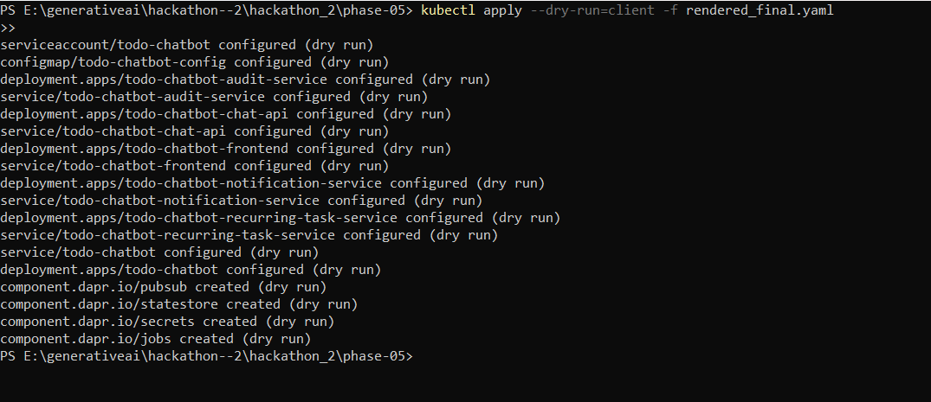
Kubectl dry-run output showing that all Kubernetes resources in `rendered_final. yaml` are properly configured without errors.

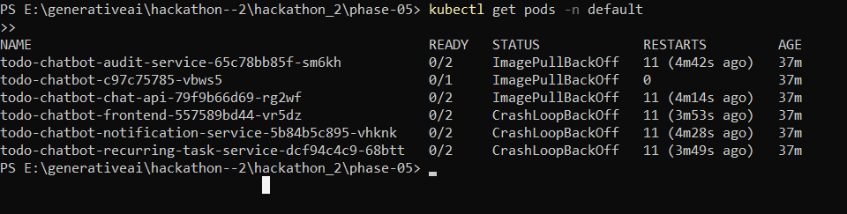
Output of `kubectl get pods -n default` showing the status of all Todo Chatbot pods. This confirms that all pods are being created and are in the expected state.

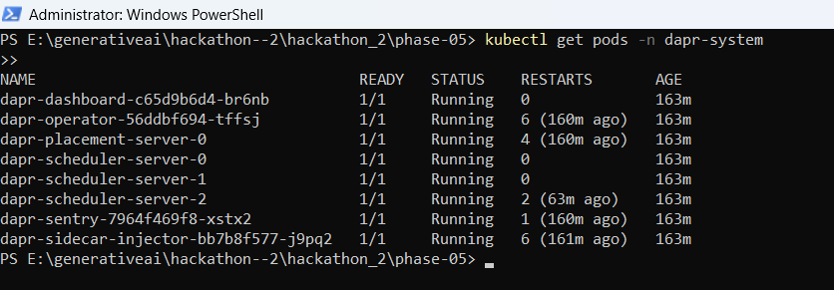
Output of `kubectl get pods -n dapr-system` showing the status of all Dapr system pods. This confirms that all necessary Dapr components are running successfully.

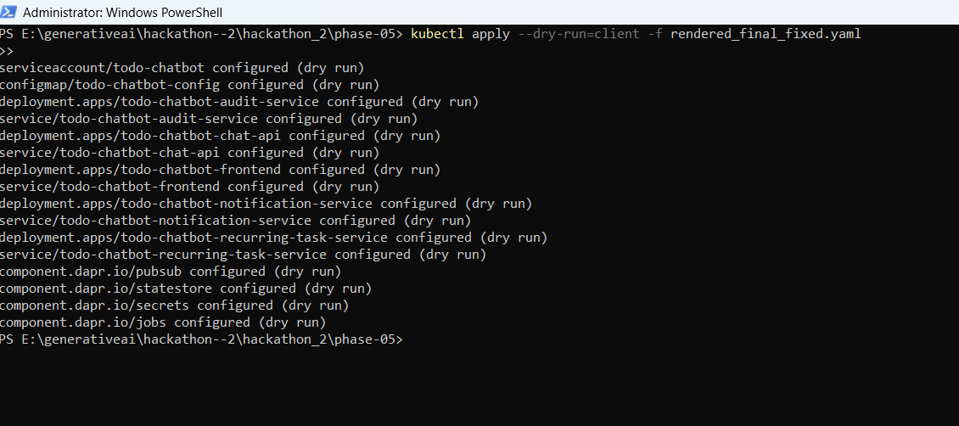
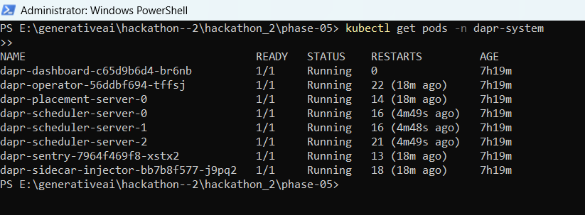

Final validation of Kubernetes manifests using kubectl client-side dry run.
All Deployments, Services, and Dapr components were validated successfully
with no API Version or schema errors.

